**Create static employee list data using spring xml configuration :**

**EmployeeAppApplication.java:**

package com.example;

import org.springframework.boot.SpringApplication;

import org.springframework.boot.autoconfigure.SpringBootApplication;

@SpringBootApplication

public class EmployeeAppApplication {

public static void main(String[] args) {

SpringApplication.run(EmployeeAppApplication.class, args);

}}

**Employee.java:**

package com.example.model;

import java.util.List;

import java.util.Date;

public class Employee {

private int id;

private String name;

private double salary;

private boolean permanent;

private Department department;

private List<Skill> skills;

private Date dateOfBirth;

public int getId() { return id; }

public void setId(int id) { this.id = id; }

public String getName() { return name; }

public void setName(String name) { this.name = name; }

public double getSalary() { return salary; }

public void setSalary(double salary) { this.salary = salary; }

public boolean isPermanent() { return permanent; }

public void setPermanent(boolean permanent) { this.permanent = permanent; }

public Department getDepartment() { return department; }

public void setDepartment(Department department) { this.department = department; }

public List<Skill> getSkills() { return skills; }

public void setSkills(List<Skill> skills) { this.skills = skills; }

public Date getDateOfBirth() { return dateOfBirth; }

public void setDateOfBirth(Date dateOfBirth) { this.dateOfBirth = dateOfBirth; }

}

**Department.java:**

package com.example.model;

public class Department {

private int id;

private String name;

public int getId() { return id; }

public void setId(int id) { this.id = id; }

public String getName() { return name; }

public void setName(String name) { this.name = name; }

}

**Skill.java:**

package com.example.model;

public class Skill {

private int id;

private String name;

public int getId() { return id; }

public void setId(int id) { this.id = id; }

public String getName() { return name; }

public void setName(String name) { this.name = name; }

}

**EmployeeDao.java:**

package com.example.dao;

import java.util.ArrayList;

import org.springframework.context.ApplicationContext;

import org.springframework.context.support.ClassPathXmlApplicationContext;

import com.example.model.Employee;

public class EmployeeDao {

private static ArrayList<Employee> EMPLOYEE_LIST;

public EmployeeDao() {

ApplicationContext context = new ClassPathXmlApplicationContext("employee.xml");

EMPLOYEE_LIST = (ArrayList<Employee>) context.getBean("employeeList");

}

public ArrayList<Employee> getAllEmployees() {

return EMPLOYEE_LIST;

}}

**EmployeeController.java:**

package com.example.controller;

import com.example.dao.EmployeeDao;

import com.example.model.Employee;

import org.springframework.web.bind.annotation.*;

import java.util.List;

*@RestController*

*@RequestMapping*("/employees")

*@CrossOrigin*(origins = "*")

public class EmployeeController {

private final EmployeeDao employeeDao;

public EmployeeController() {

this.employeeDao = new EmployeeDao();

}

*@GetMapping*

public List<Employee> getAllEmployees() {

return employeeDao.getAllEmployees();

}

*@GetMapping*("/{id}")

public Employee getEmployeeById(*@PathVariable* int id) {

return employeeDao.getAllEmployees()

.stream()

.filter(emp -> emp.getId() == id)

.findFirst()

.orElse(null);

}}

**Employee.xml:**

<?xml version="1.0" encoding="UTF-8"?>

<beans xmlns="http://www.springframework.org/schema/beans"

xmlns:xsi="http://www.w3.org/2001/XMLSchema-instance"

xsi:schemaLocation="http://www.springframework.org/schema/beans

http://www.springframework.org/schema/beans/spring-beans.xsd">

<bean id="dept1" class="com.example.model.Department">

<property name="id" value="1"/>

<property name="name" value="HR"/>

</bean>

<bean id="dept2" class="com.example.model.Department">

<property name="id" value="2"/>

<property name="name" value="IT"/>

</bean>

<bean id="skill1" class="com.example.model.Skill">

<property name="id" value="1"/>

<property name="name" value="Java"/>

</bean>

<bean id="skill2" class="com.example.model.Skill">

<property name="id" value="2"/>

<property name="name" value="Angular"/>

</bean>

<bean id="employee1" class="com.example.model.Employee">

<property name="id" value="101"/>

<property name="name" value="Alice"/>

<property name="salary" value="50000"/>

<property name="permanent" value="true"/>

<property name="department" ref="dept1"/>

<property name="skills">

<list>

<ref bean="skill1"/>

<ref bean="skill2"/>

</list>

</property>

</bean>

<bean id="employee2" class="com.example.model.Employee">

<property name="id" value="102"/>

<property name="name" value="Bob"/>

<property name="salary" value="60000"/>

<property name="permanent" value="false"/>

<property name="department" ref="dept2"/>

<property name="skills">

<list>

<ref bean="skill1"/>

</list>

</property>

</bean>

<bean id="employeeList" class="java.util.ArrayList">

<constructor-arg>

<list>

<ref bean="employee1"/>

<ref bean="employee2"/>

</list>

</constructor-arg>

</bean>

</beans>

**pom.xml:**

<?xml version="1.0" encoding="UTF-8"?>

<project xmlns="http://maven.apache.org/POM/4.0.0" xmlns:xsi="http://www.w3.org/2001/XMLSchema-instance"

xsi:schemaLocation="http://maven.apache.org/POM/4.0.0 https://maven.apache.org/xsd/maven-4.0.0.xsd">

<modelVersion>4.0.0</modelVersion>

<parent>

<groupId>org.springframework.boot</groupId>

<artifactId>spring-boot-starter-parent</artifactId>

<version>3.5.3</version>

<relativePath/>

</parent>

<groupId>com.example</groupId>

<artifactId>employee-app</artifactId>

<version>0.0.1-SNAPSHOT</version>

<name>employee-app</name>

<description>Demo project for Spring Boot</description>

<url/>

<licenses>

<license/>

</licenses>

<developers>

<developer/>

</developers>

<scm>

<connection/>

<developerConnection/>

<tag/>

<url/>

</scm>

<properties>

<java.version>17</java.version>

</properties>

<dependencies>

<dependency>

<groupId>org.springframework.boot</groupId>

<artifactId>spring-boot-devtools</artifactId>

<scope>runtime</scope>

<optional>true</optional>

</dependency>

<dependency>

<groupId>org.projectlombok</groupId>

<artifactId>lombok</artifactId>

<optional>true</optional>

</dependency>

<dependency>

<groupId>org.springframework.boot</groupId>

<artifactId>spring-boot-starter-test</artifactId>

<scope>test</scope>

</dependency>

<dependency>

<groupId>org.springframework</groupId>

<artifactId>spring-context</artifactId>

</dependency>

<dependency>

<groupId>com.fasterxml.jackson.datatype</groupId>

<artifactId>jackson-datatype-jsr310</artifactId>

</dependency>

</dependencies>

<build>

<plugins>

<plugin>

<groupId>org.apache.maven.plugins</groupId>

<artifactId>maven-compiler-plugin</artifactId>

<configuration>

<annotationProcessorPaths>

<path>

<groupId>org.projectlombok</groupId>

<artifactId>lombok</artifactId>

</path>

</annotationProcessorPaths>

</configuration>

</plugin>

<plugin>

<groupId>org.springframework.boot</groupId>

<artifactId>spring-boot-maven-plugin</artifactId>

<configuration>

<excludes>

<exclude>

<groupId>org.projectlombok</groupId>

<artifactId>lombok</artifactId>

</exclude>

</excludes>

</configuration>

</plugin>

</plugins>

</build>

</project>

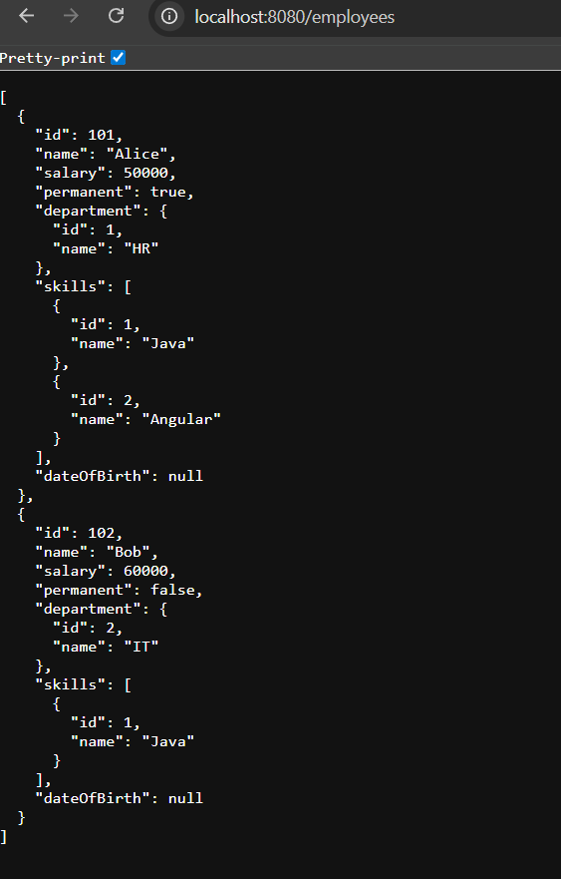

**Create REST service to gets all employees**: **EmployeeAppApplication.java:**

package com.example;

import org.springframework.boot.SpringApplication;

import org.springframework.boot.autoconfigure.SpringBootApplication;

*@SpringBootApplication*

public class EmployeeAppApplication {

public static void main(String[] args) {

SpringApplication.*run*(EmployeeAppApplication.class, args);

}}

**Employee.java:**

package com.example.model;

import java.util.List;

import java.util.Date;

public class Employee {

private int id;

private String name;

private double salary;

private boolean permanent;

private Department department;

private List<Skill> skills;

private Date dateOfBirth;

public int getId() { return id; }

public void setId(int id) { this.id = id; }

public String getName() { return name; }

public void setName(String name) { this.name = name; }

public double getSalary() { return salary; }

public void setSalary(double salary) { this.salary = salary; }

public boolean isPermanent() { return permanent; }

public void setPermanent(boolean permanent) { this.permanent = permanent; }

public Department getDepartment() { return department; }

public void setDepartment(Department department) { this.department = department; }

public List<Skill> getSkills() { return skills; }

public void setSkills(List<Skill> skills) { this.skills = skills; }

public Date getDateOfBirth() { return dateOfBirth; }

public void setDateOfBirth(Date dateOfBirth) { this.dateOfBirth = dateOfBirth; }

}

**Department.java:**

package com.example.model;

public class Department {

private int id;

private String name;

public int getId() { return id; }

public void setId(int id) { this.id = id; }

public String getName() { return name; }

public void setName(String name) { this.name = name; }

}

**EmployeeController.java:**

package com.example.controller;

import com.example.model.Employee;

import com.example.service.EmployeeService;

import org.springframework.web.bind.annotation.*;

import java.util.List;

*@RestController*

*@RequestMapping*("/employees")

*@CrossOrigin*(origins = "*")

public class EmployeeController {

private final EmployeeService employeeService;

public EmployeeController() {

this.employeeService = new EmployeeService();

}

*@GetMapping*

public List<Employee> getAllEmployees() {

return employeeService.getAllEmployees();

}}

**EmployeeService.java:**

package com.example.service;

import com.example.dao.EmployeeDao;

import com.example.model.Employee;

import org.springframework.stereotype.Service;

import org.springframework.transaction.annotation.Transactional;

import java.util.List;

*@Service*

public class EmployeeService {

private final EmployeeDao employeeDao;

public EmployeeService() {

this.employeeDao = new EmployeeDao();

}

*@Transactional*

public List<Employee> getAllEmployees() {

return employeeDao.getAllEmployees();

}}

**EmployeeDao.java:**

package com.example.dao;

import java.util.ArrayList;

import org.springframework.context.ApplicationContext;

import org.springframework.context.support.ClassPathXmlApplicationContext;

import com.example.model.Employee;

public class EmployeeDao {

private static ArrayList<Employee> EMPLOYEE_LIST;

public EmployeeDao() {

ApplicationContext context = new ClassPathXmlApplicationContext("employee.xml");

EMPLOYEE_LIST = (ArrayList<Employee>) context.getBean("employeeList");

}

public ArrayList<Employee> getAllEmployees() {

return EMPLOYEE_LIST;

}}

**Employee.xml:**

<?xml version="1.0" encoding="UTF-8"?>

<beans xmlns="http://www.springframework.org/schema/beans"

xmlns:xsi="http://www.w3.org/2001/XMLSchema-instance"

xsi:schemaLocation="http://www.springframework.org/schema/beans

http://www.springframework.org/schema/beans/spring-beans.xsd">

<bean id="dept1" class="com.example.model.Department">

<property name="id" value="1"/>

<property name="name" value="HR"/>

</bean>

<bean id="dept2" class="com.example.model.Department">

<property name="id" value="2"/>

<property name="name" value="IT"/>

</bean>

<bean id="skill1" class="com.example.model.Skill">

<property name="id" value="1"/>

<property name="name" value="Java"/>

</bean>

<bean id="skill2" class="com.example.model.Skill">

<property name="id" value="2"/>

<property name="name" value="Angular"/>

</bean>

<bean id="employee1" class="com.example.model.Employee">

<property name="id" value="101"/>

<property name="name" value="Alice"/>

<property name="salary" value="50000"/>

<property name="permanent" value="true"/>

<property name="department" ref="dept1"/>

<property name="skills">

<list>

<ref bean="skill1"/>

<ref bean="skill2"/>

</list>

</property>

</bean>

<bean id="employee2" class="com.example.model.Employee">

<property name="id" value="102"/>

<property name="name" value="Bob"/>

<property name="salary" value="60000"/>

<property name="permanent" value="false"/>

<property name="department" ref="dept2"/>

<property name="skills">

<list>

<ref bean="skill1"/>

</list>

</property>

</bean>

<bean id="employeeList" class="java.util.ArrayList">

<constructor-arg>

<list>

<ref bean="employee1"/>

<ref bean="employee2"/>

</list>

</constructor-arg>

</bean>

</beans>

**GET employees - Postman**:

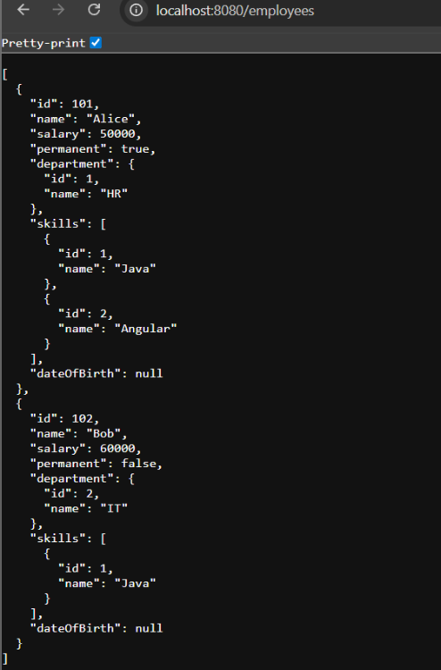

**Create REST service for department:**

**Department.java:**

package com.example.model;

public class Department {

private int id;

private String name;

public Department(int id, String name) {

this.id = id;

this.name = name;

}

public Department() {}

public int getId() {

return id;

}

public void setId(int id) {

this.id = id;

}

public String getName() {

return name;

}

public void setName(String name) {

this.name = name;

}

}

**DepartmentDao.java:**

package com.example.dao;

import com.example.model.Department;

import org.springframework.stereotype.Repository;

import java.util.List;

import java.util.ArrayList;

*@Repository*

public class DepartmentDao {

private List<Department> departmentList;

public void setDepartmentList(List<Department> departmentList) {

this.departmentList = departmentList;

}

public DepartmentDao() {

departmentList = new ArrayList<>();

departmentList.add(new Department(1, "HR"));

departmentList.add(new Department(2, "IT"));

}

public List<Department> getAllDepartments() {

return departmentList;

}

}

**DepartmentService.java:**

package com.example.service;

import com.example.dao.DepartmentDao;

import com.example.model.Department;

import org.springframework.beans.factory.annotation.Autowired;

import org.springframework.stereotype.Service;

import java.util.List;

*@Service*

public class DepartmentService {

*@Autowired*

private DepartmentDao departmentDao;

public List<Department> getAllDepartments() {

return departmentDao.getAllDepartments();

}

}

**DepartmentController.java:**

package com.example.controller;

import com.example.dao.DepartmentDao;

import com.example.model.Department;

import org.springframework.beans.factory.annotation.Autowired;

import org.springframework.web.bind.annotation.*;

import java.util.List;

*@RestController*

*@RequestMapping*("/department")

public class DepartmentController {

*@Autowired*

private DepartmentDao departmentDao;

*@GetMapping*

public List<Department> getAllDepartments() {

return departmentDao.getAllDepartments();

}

}

**EmployeeAppApplication.java:**

package com.example;

import org.springframework.boot.SpringApplication;

import org.springframework.boot.autoconfigure.SpringBootApplication;

import org.springframework.context.annotation.ImportResource;

*@SpringBootApplication*

public class EmployeeAppApplication {

public static void main(String[] args) {

SpringApplication.*run*(EmployeeAppApplication.class, args);

}

}

